Third Grade
Key Concept 2:
Physical Maps Lesson
Overview:
This lesson is designed for students to learn about the different kinds of maps while learning about the different regions and other facts about Arkansas. If you have the ability to get a class set of computers, it can be integrated with hands on technology and used to practice and spiral using and making a key. If you do not have access to a class set, the lesson is easily adapted to use a projector.

Materials Needed:
- World Map
- Globe
- Student Worksheet
- Teacher Computer and Projector Screen

Key Vocabulary:
Longitude
Latitude
Equator
Meridian
Prime Meridian
Geography
Map
Equator

Objectives:
G.8.3.1 Use maps to describe the spatial organization of the community using relative location, distance, direction, and scale
G.8.3.2 Use thematic maps and other geographic representations to describe physical and human characteristics of a variety of places in Arkansas and the interactions that shape them
G.8.3.3 Construct maps and other geographic representations of the local community, including physical and human characteristics, title, legend, and compass rose

Instructions:

- Explain to the students that it is important for us to where we live and the areas around we live. Tell the students that we live in (Use your city name), Arkansas. First we will find Little Rock, the capital city, on the Arkansas map. Then we will find the county and city we live in.

- It is important to know what grows in Arkansas so that we can preserve our land. We also want to know where cows, cotton, soybean grows. Where and how they grow.

- We can use maps to determine this. We will look at several maps.

- Walk students through the packet provided with information on the different regions of Arkansas, spiraling in using a key to help read a map as you go.

- Integrate technology if you have computers for all of your students, if not have volunteers come up to your computer to do the activities below.

- Model for the students how to copy the blank map, paint their County and put a star where Little Rock should be. Be sure to ask/explain why there is a star on Little Rock.

- Next look at the how the urban and rural are distinguished on the map. Where do we live? Do we live in the urban area or rural area?

- After you look at the map, let them look at different types of maps. Now, we will look at different resources that come from Arkansas. These resources are shipped throughout the U.S. or maybe even the nation.

- Here are some great suggestions on where to find the best Arkansas interactive maps to use in your classroom.

  - http://www.agfc.com/!userfiles/int_images/hunting/checkstation_map.jpg
    - map of Arkansas counties
  - http://www.arkansas.com/maps/
    - click on interactive map, then only select the topography to see the highlands and lowlands of Arkansas
  - http://www.arkansas.com/maps/topo_maps.aspx
    - A better map that you’ll want to use to copy and paste for the official 6 natural regions of Arkansas.
  - http://en.wikipedia.org/wiki/Arkansas
    - from Wikipedia: Arkansas with links highlighted in blue
  - http://www.encyclopediaofarkansas.net/encyclopedia/entry-detail.aspx?entryID=401
    - From the EncylopediaofArkansas.net
    - Tells how the natural divisions were created. More for teachers than for k-5 students
  - http://www.mawpt.org/default.asp
    - Info on the wetlands of Arkansas
  - http://www.deltabyways.com/region.htm
    - the Mississippi Delta
  - http://www.arnatural.org/forestry/resources.htm
    - Forestry resources for Arkansas by region
  - http://www.classbrain.com/artstate/publish/arkansas_natural_resources.shtml
    - Natural resources
  - Great maps for agriculture
    - http://www.aragriculture.org/
    - http://www.arfb.com/commodity_marketing/ar_commodity_info/ (BEST)
    - http://www.state.ar.us/agc/AR2000map.pdf
    - http://www.state.ar.us/agc/arminmap.pdf

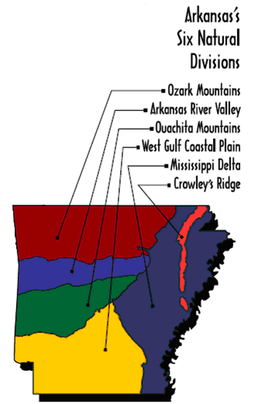
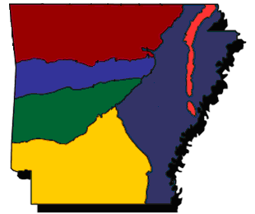
The six natural regions of Arkansas


Ozark Mountains
Arkansas River Valley
Ouachita Mountains
West Gulf Coastal Plains
Mississippi Delta
Crowley’s Ridge
Resources and goods of Arkansas
diamonds
forestry
dairy
chicken
wheat
cotton
soybeans

rice

Tomatoes & watermelon
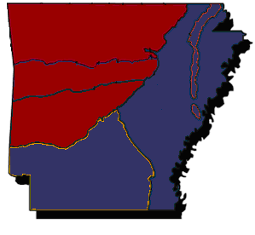
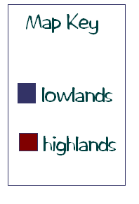
Arkansas
Highlands and Lowlands
Arkansas
My state, my county, my city and my capital
(Watch to see how to do it so you aren’t lost when you do yours on your own!)

Directions: use Microsoft paint and this picture of Arkansas to identify your county and the capital city of Little Rock.
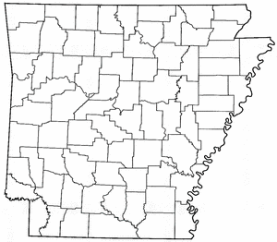
Map Key:

My County

__________________

Little Rock

Arkansas
My state, my county, my city and my capital

Directions: use Microsoft paint and this picture of Arkansas to identify your county, your city and the capital city of Little Rock. When you have finished, get your work checked, then paint all the counties and make a key to go with your map.

Example:
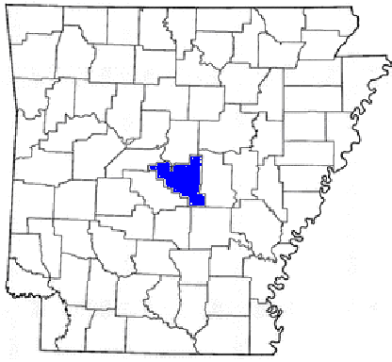
Map Key:

Pulaski County

Little Rock

