Kindergarten
Key Concept 5:
Transportation Lesson

Overview:

This lesson scaffolds the vocabulary and spelling of different types of transportation as well as teaches students how people and products get from place to place.
For the Teacher:

You may want to review expectations for moving safely around the room, or do more of an “I have.. Who has…” auditory if classroom management is not on par with children walking around the room without issue. You will need to model what it looks like before doing this activity if you expect it to work. Printing/cutting materials and thinking about odd/even numbers in your classroom is also a pre-planning step that may be time-consuming.

Materials Needed:

- Scissors (for the teacher, not the students)
- Packet (included)
- Space to move around
- Projector of pictures of modes of transportation (optional, you may wish to read a book you have or show pictures from the packet if technology is unavailable)

Key Vocabulary:

Car
Truck
Airplane
Train
Boat
Ferry
Bus
Horse
Buggy
Bicycle
(Any additional modes of transportation you would like to include)

Objectives:

E.5.K.3 Identify markets in the community
E.6.K.3 Discuss examples of public goods and services
E.7.K.1 Discuss why people trade goods and services
G.10.K.2 Identify people and goods that move from place to place

Instructions:

Day 1:
- Discuss different modes of transportation on land, sea and in the air.
- Talk about how people get to where they are going (school bus, ferry boat, car etc.)
- Incorporate field trips if possible. Take a trip on a school bus, walk around the school parking lot to look at cars, visit the airport, bus station or train station. Watch videos that show different forms of transportation (optional links below). Look at travel magazines if you don’t have a projector. Ask if anyone has been on a plane ... a train ... a horse ... etc. Ask how students get to school every day. How do kids in other countries travel? Leave lots of time for discussion.
- You may want to review some safety rules (seatbelts in cars, obeying traffic signals, walk and don't walk signs, holding hands when crossing the street…). Don't forget to discuss how products are delivered ... couriers with trucks, airplanes etc. How does the mail travel?
- Useful links:
  - https://www.youtube.com/watch?v=X2a_9i87Qno
  - https://www.youtube.com/watch?v=npdJM4tT6Wo
Day 2:
- Prepare pairs of cards of your choice which contain matching information on them. From the attachments. Make sure each student has one card and that there is in fact another student who has the match. If you have a large class, you may use multiple copies of the same card so that everyone has a pair.
  - Shuffle the cards and distribute one to each student
  - Allow students to mix and mingle until they find their match.
  - When everyone is paired up, you can review the content by asking each pair to make a sound the mode of transportation makes or to name where/how it moves (land, water air… road, airport, train station.. This depends on how in depth you would like to go with it and how much choice you would like to allow your students. You know your class best. Do what works for you.)
  - You may wish to do this more than one time to get it to stick or follow up with a matching or memory game with the cards. You may wish to start with only a few and add more or new ones each time you play.
  - When you are finished, you can use them for your bulletin board if you make a little town and have the students color and place the vehicles where they would go in the correct part of the community (ex: make a hospital and have the ambulance go in front of it, airplane in the sky, school bus in front of the school, mail truck in front of or by a mailbox…)

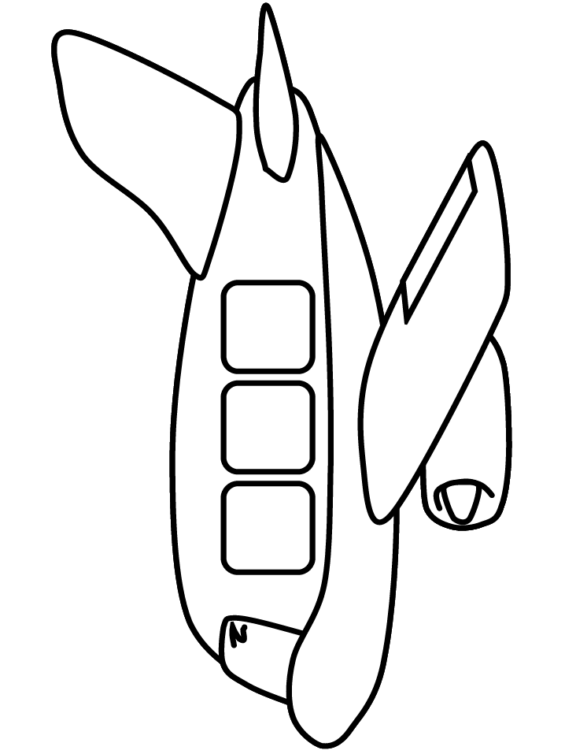 | Airplane
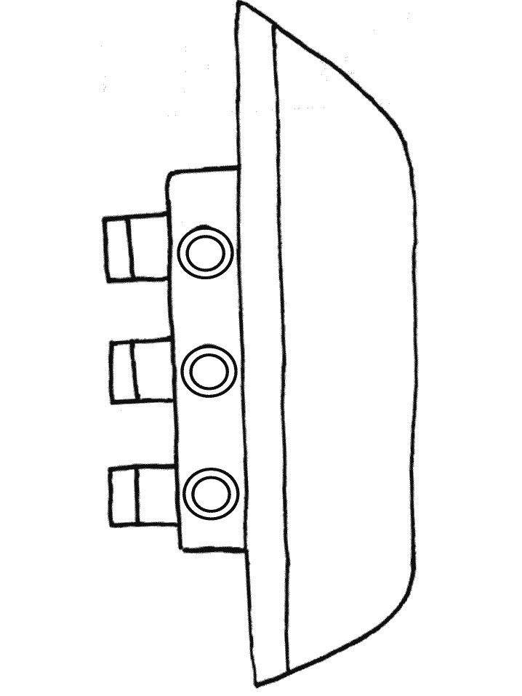 | Ship
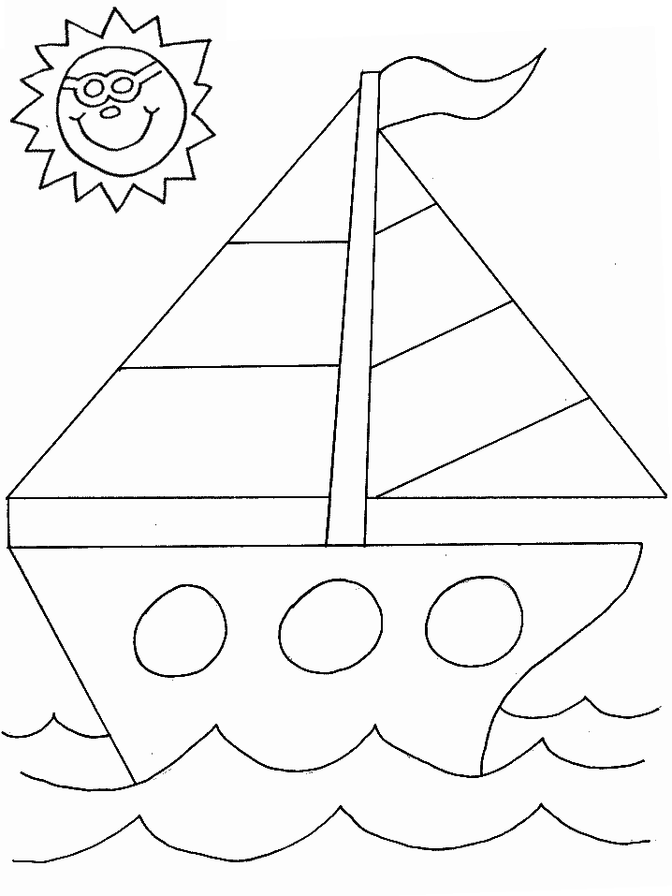 | Sail Boat
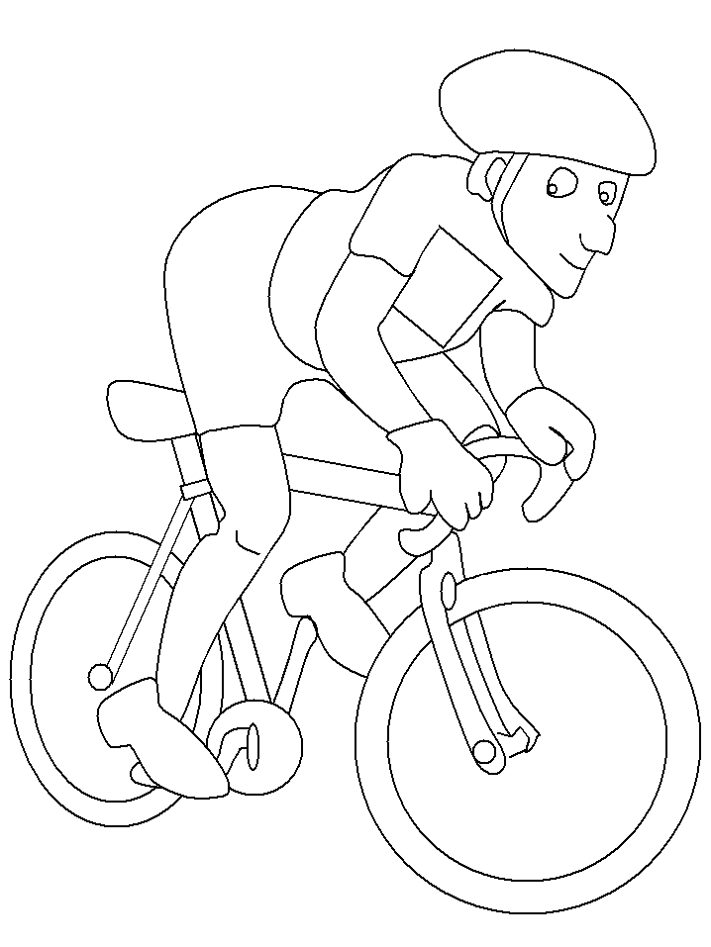 | Bicycle
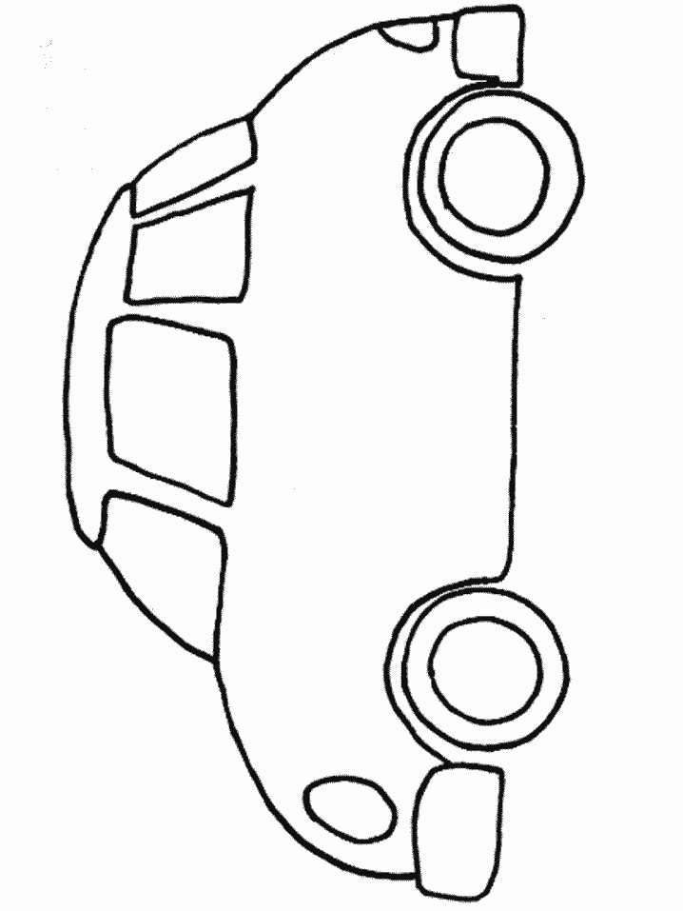 | Car
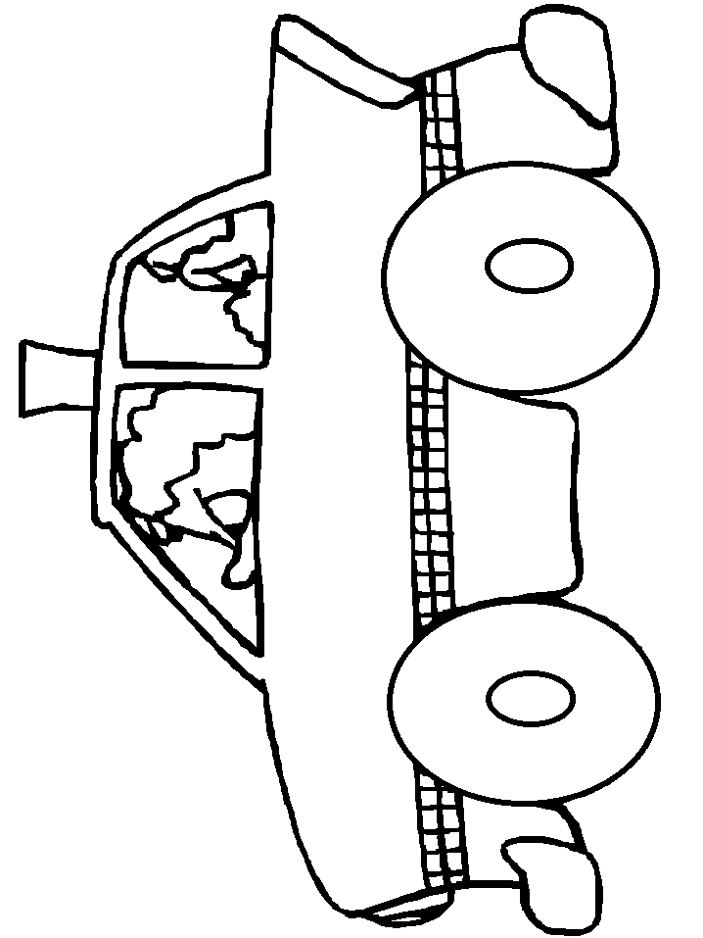 | Taxi  Cab
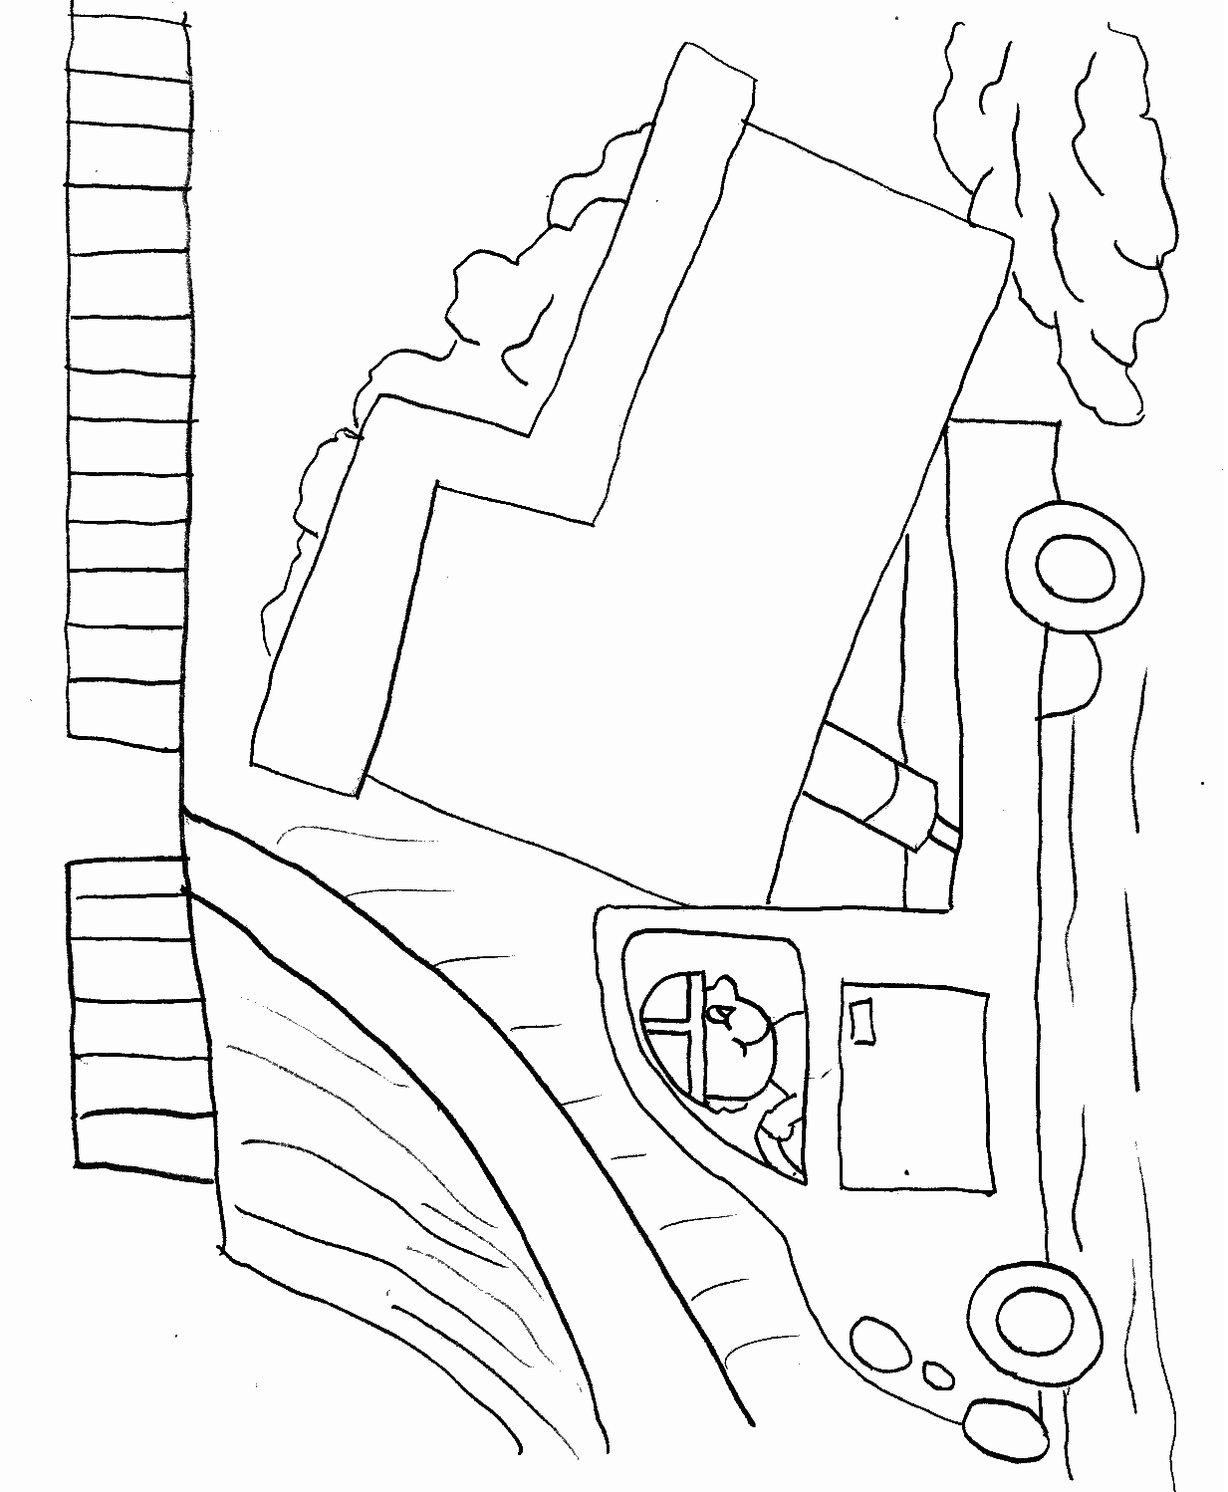 | Dump Truck
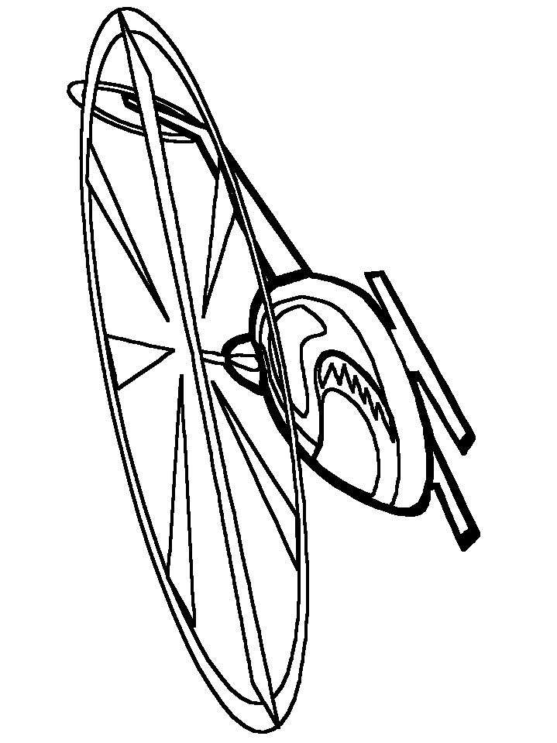 | Helicopter
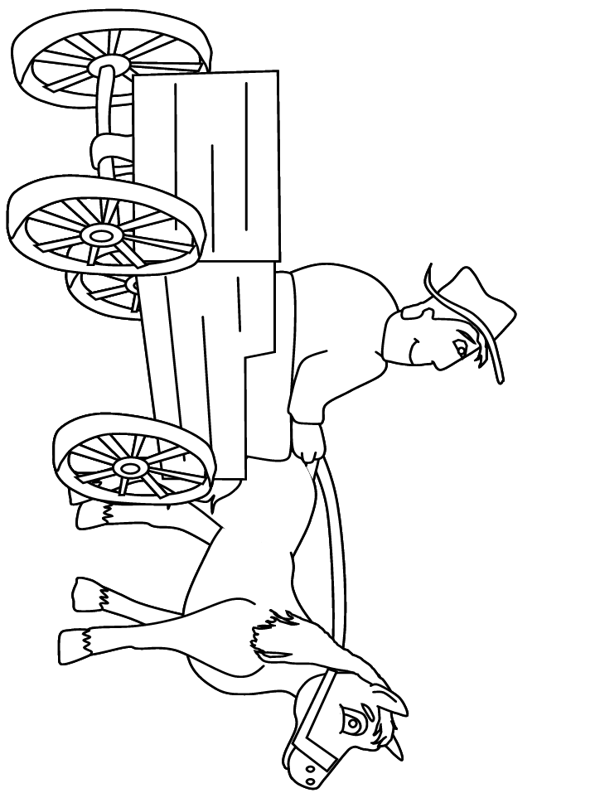 | Horse and Buggy
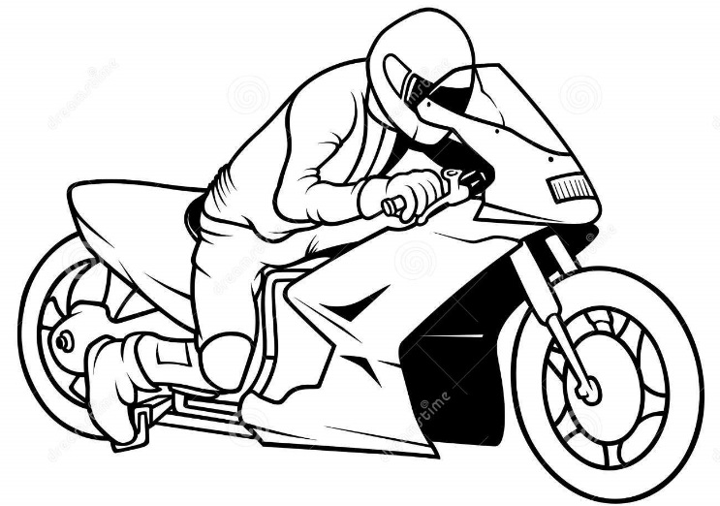 | Motorcycle
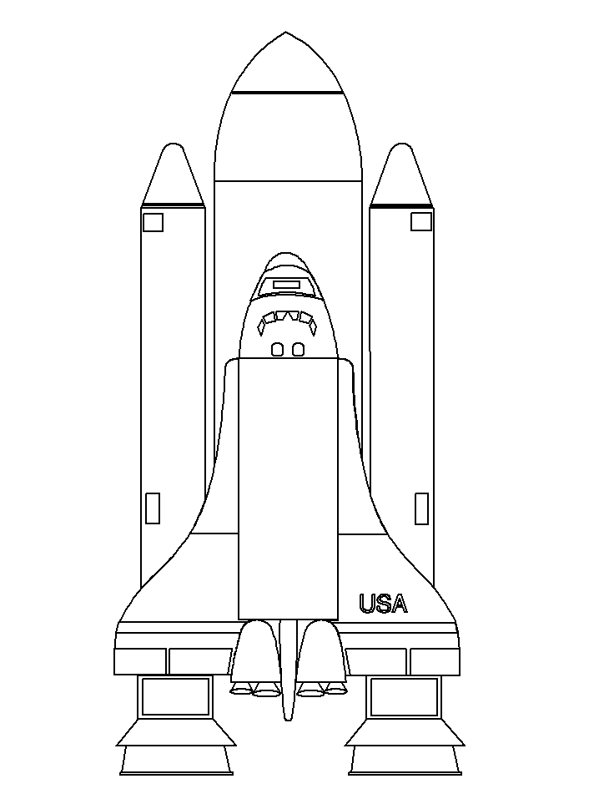 | Space Shuttle
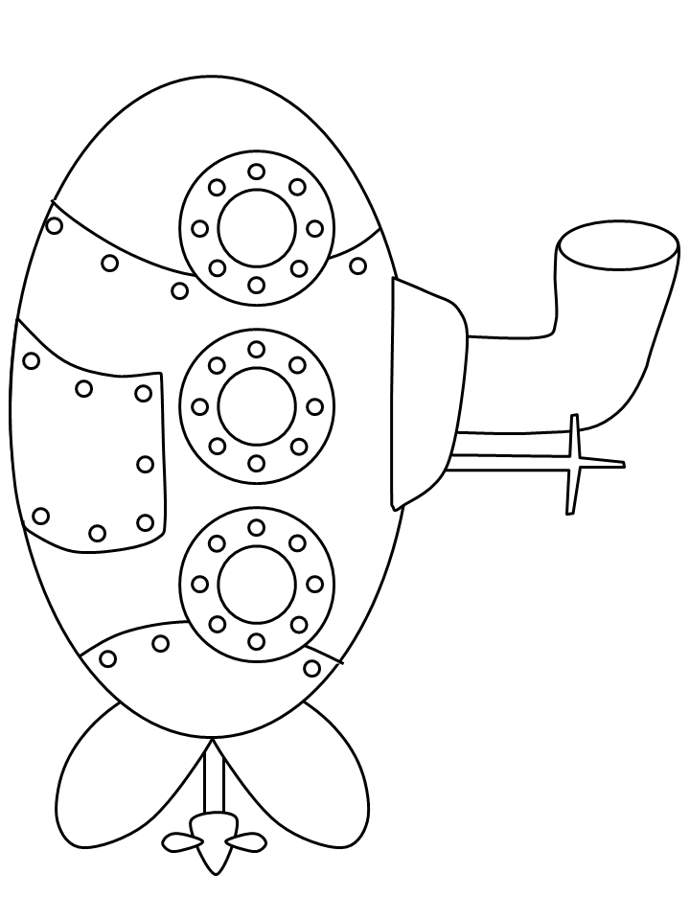 | Submarine
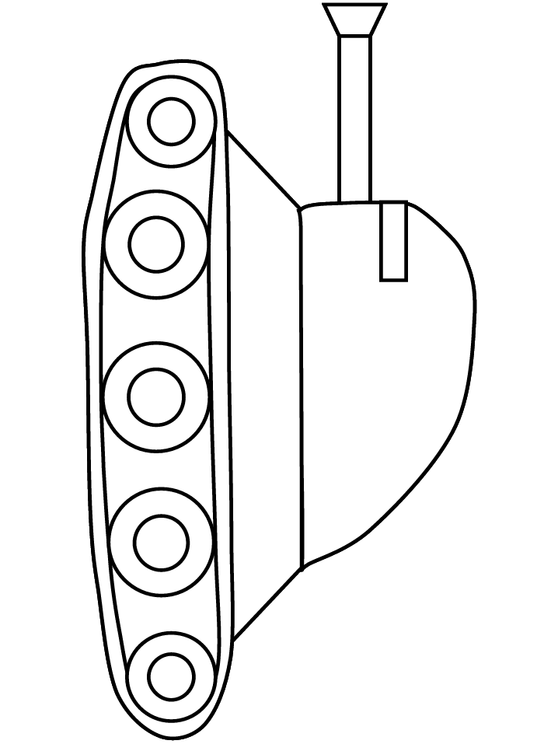 | Tank
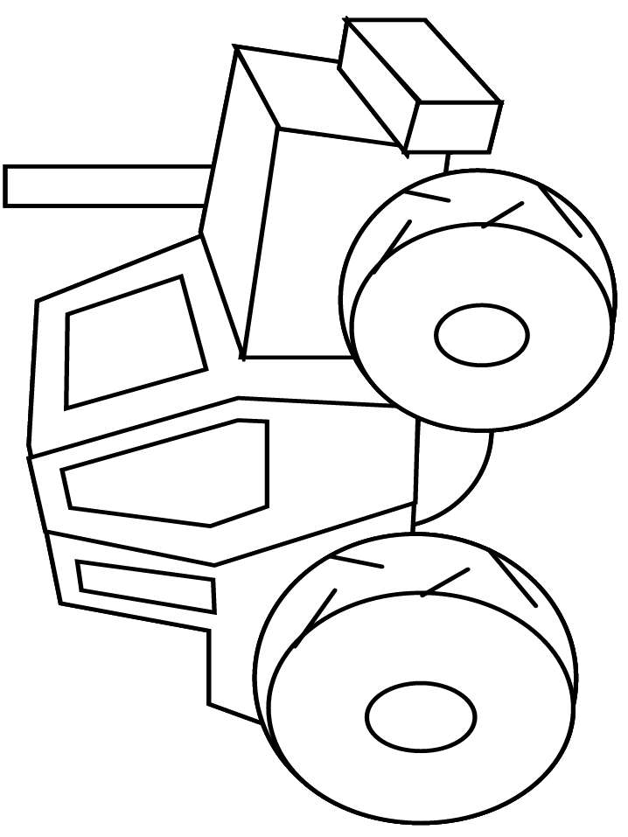 | Tractor
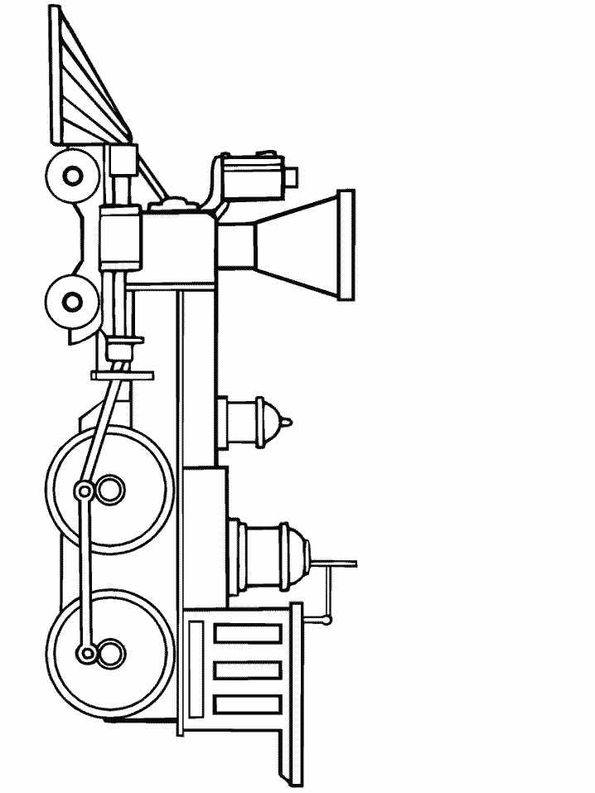 | Train
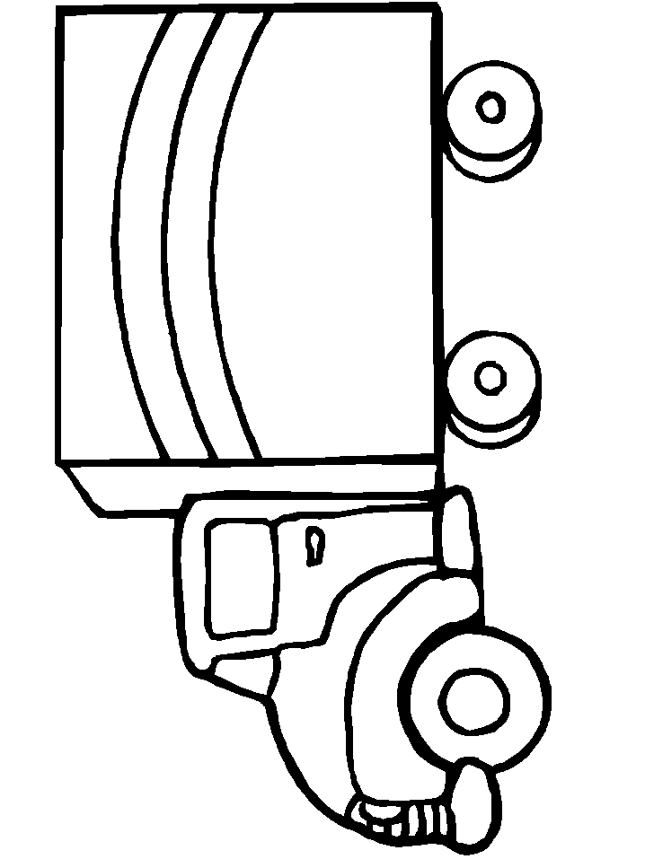 | Delivery Truck
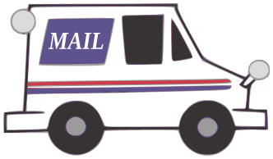 | Mail Truck
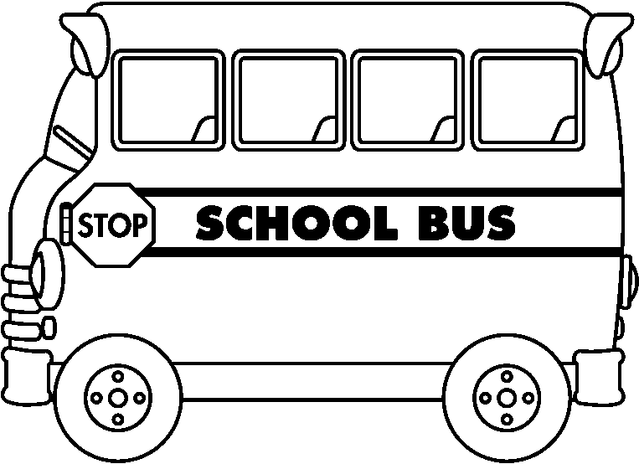 | School Bus
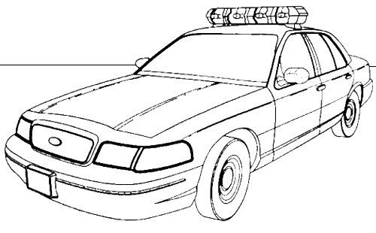 | Police Car
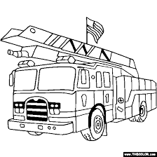 | Fire  Truck
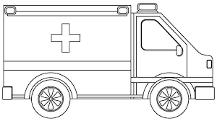 | Ambulance

For more or different transportation vehicles, visit: http://www.coloring.ws/transportation.htm

